**Fundamentals of Programming**

**Lab Manual 6**

**1st SEMESTER**

**Session: ME-15 Section: C**

|  |  |
| --- | --- |
| **ABDUL RAFEH** | **417648** |

**School of Mechanical and Manufacturing Engineering**

**LAB TASK:**

**PROGRAM 1:**

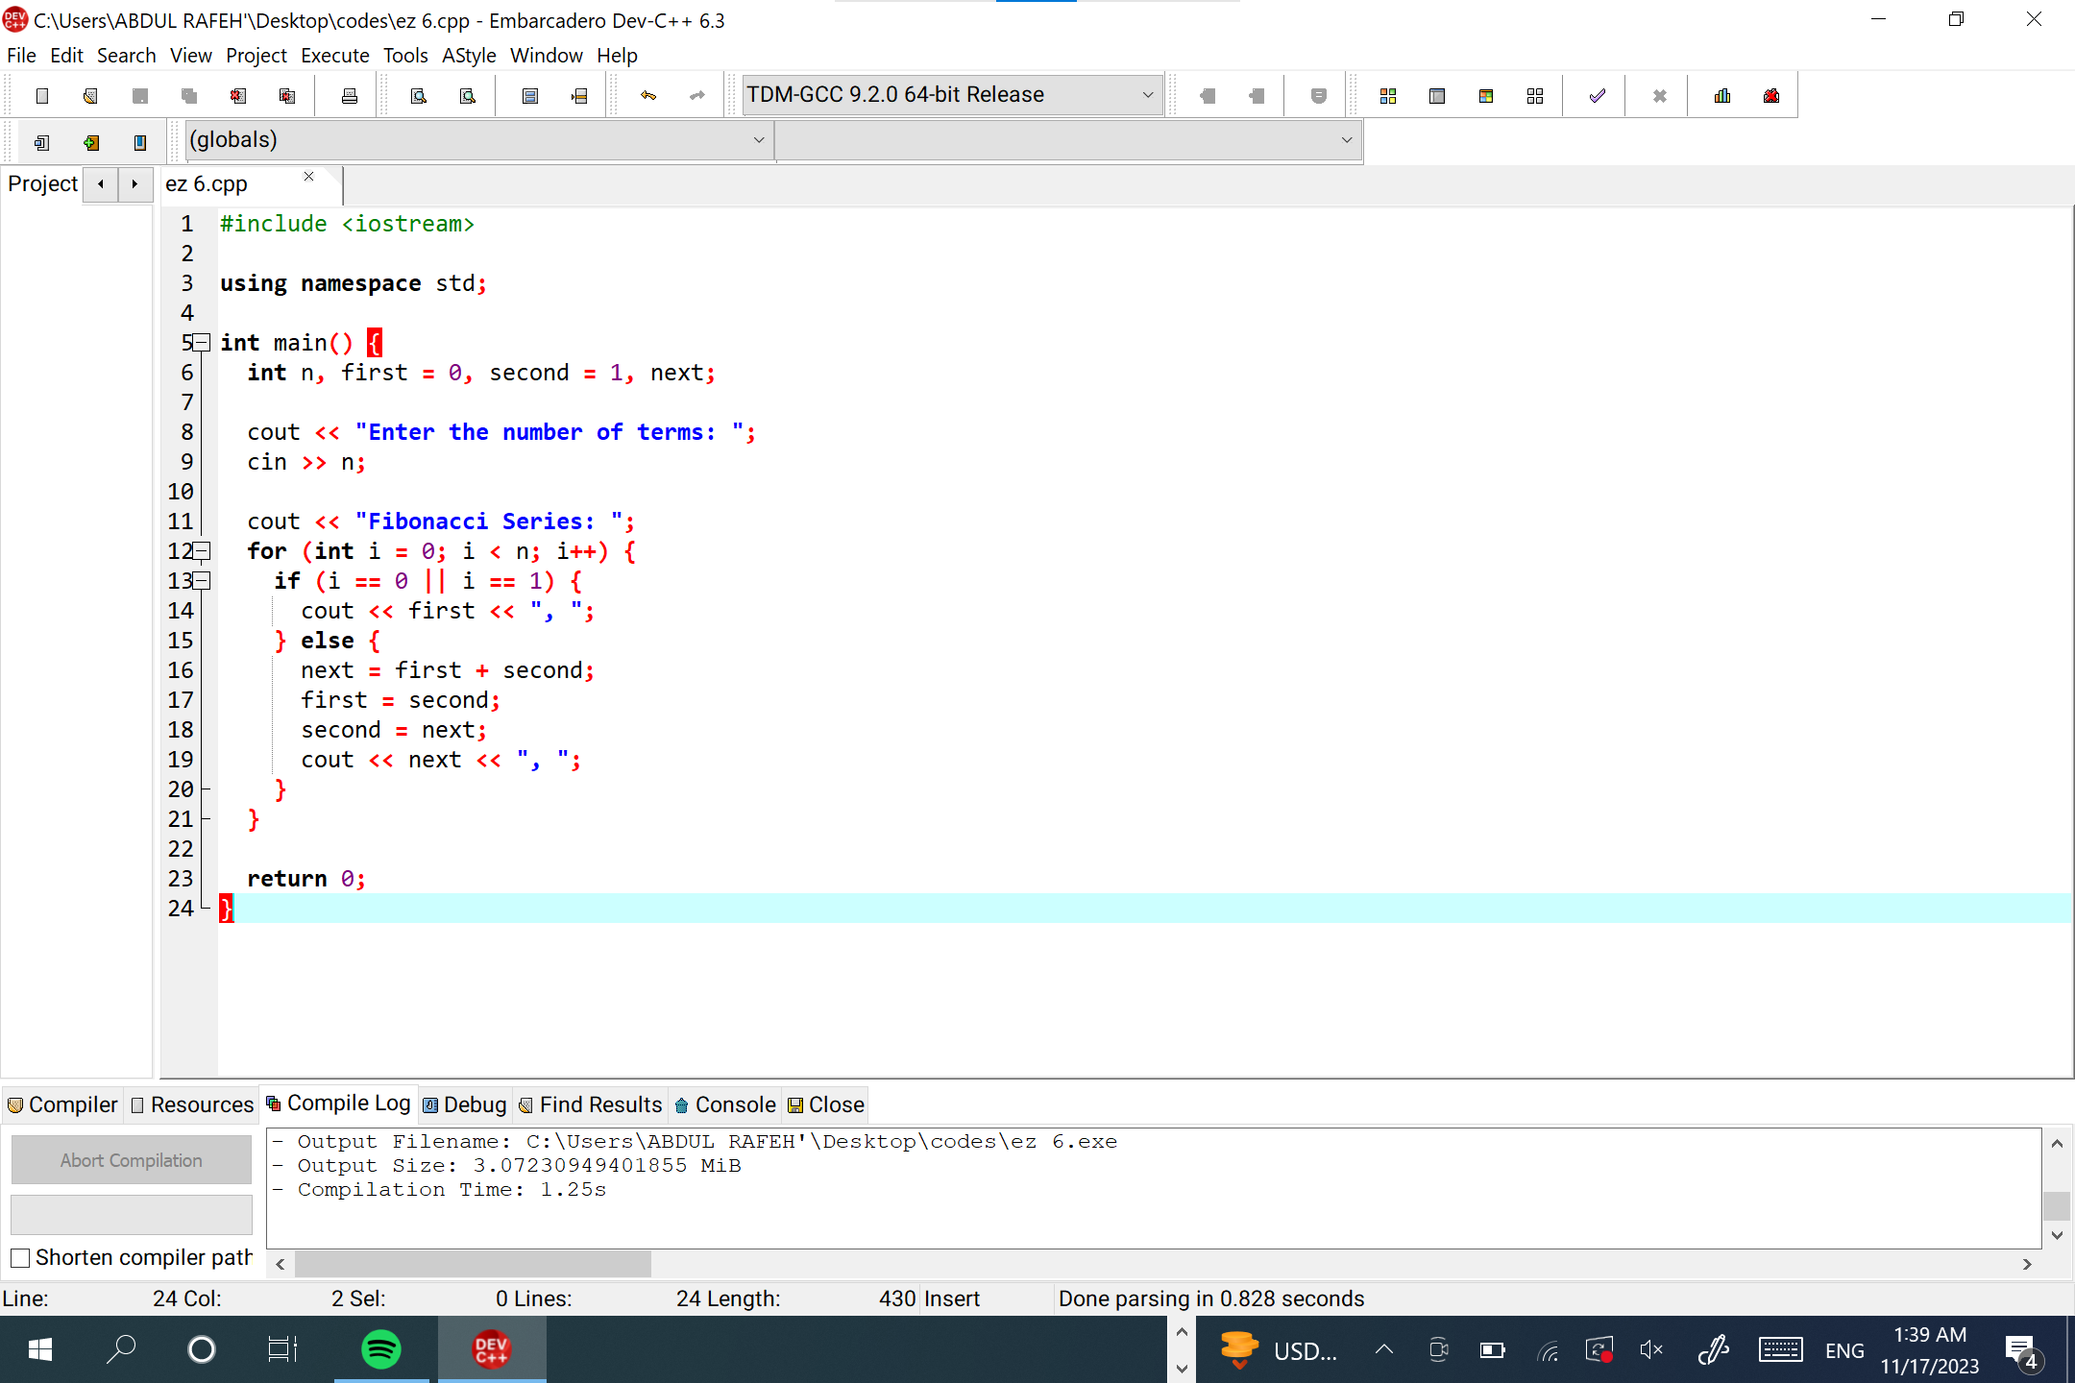

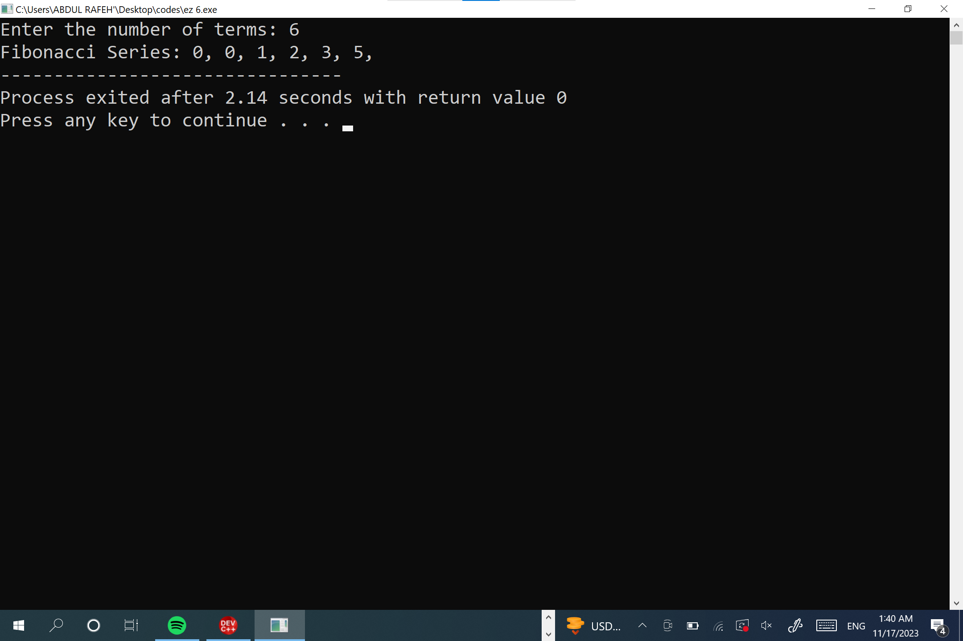

**PROGRAM 2:**

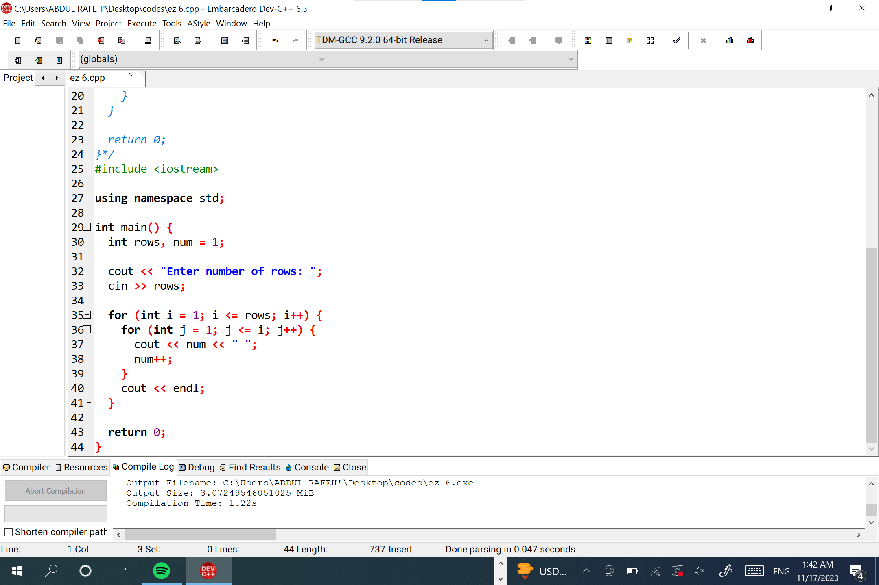

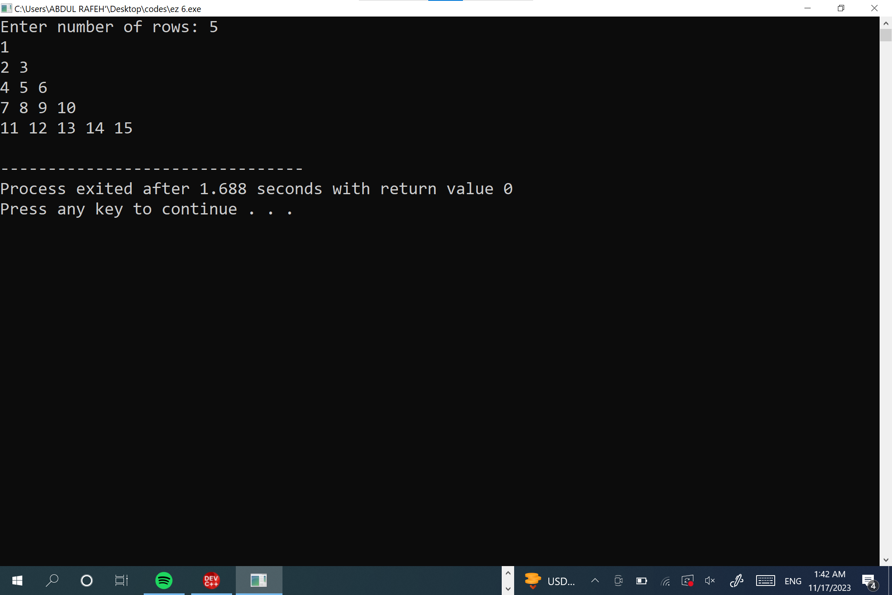

**HOME TASK:**

**PROGRAM 1:**

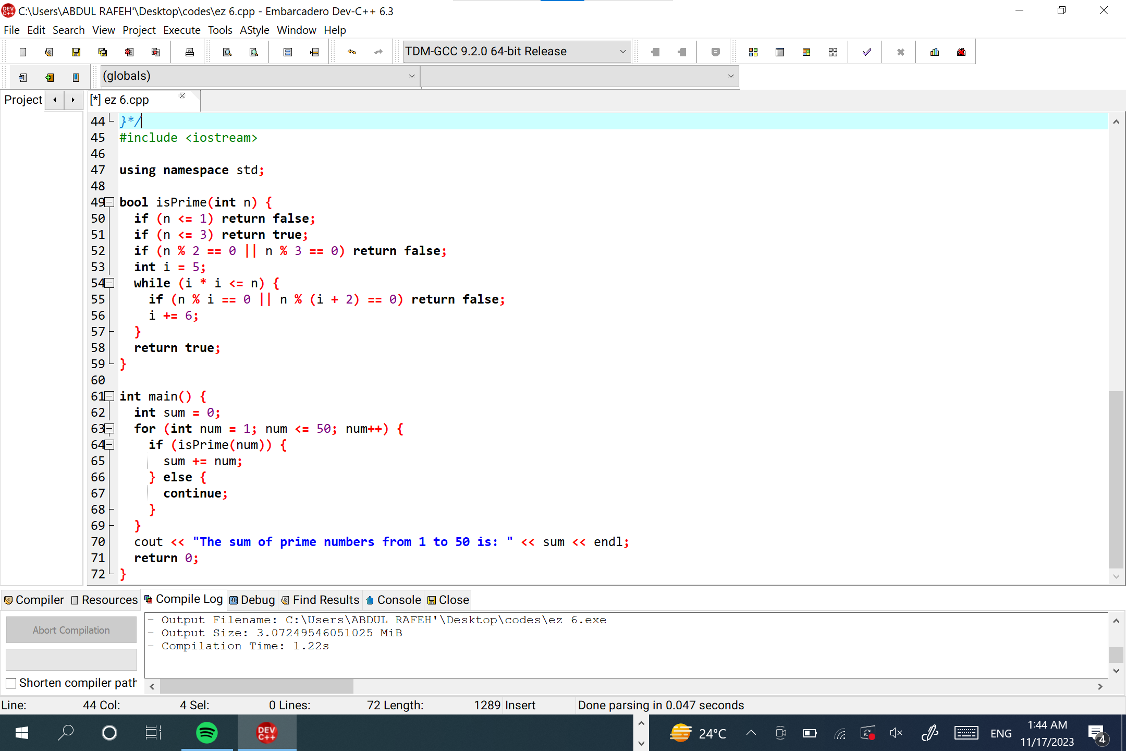

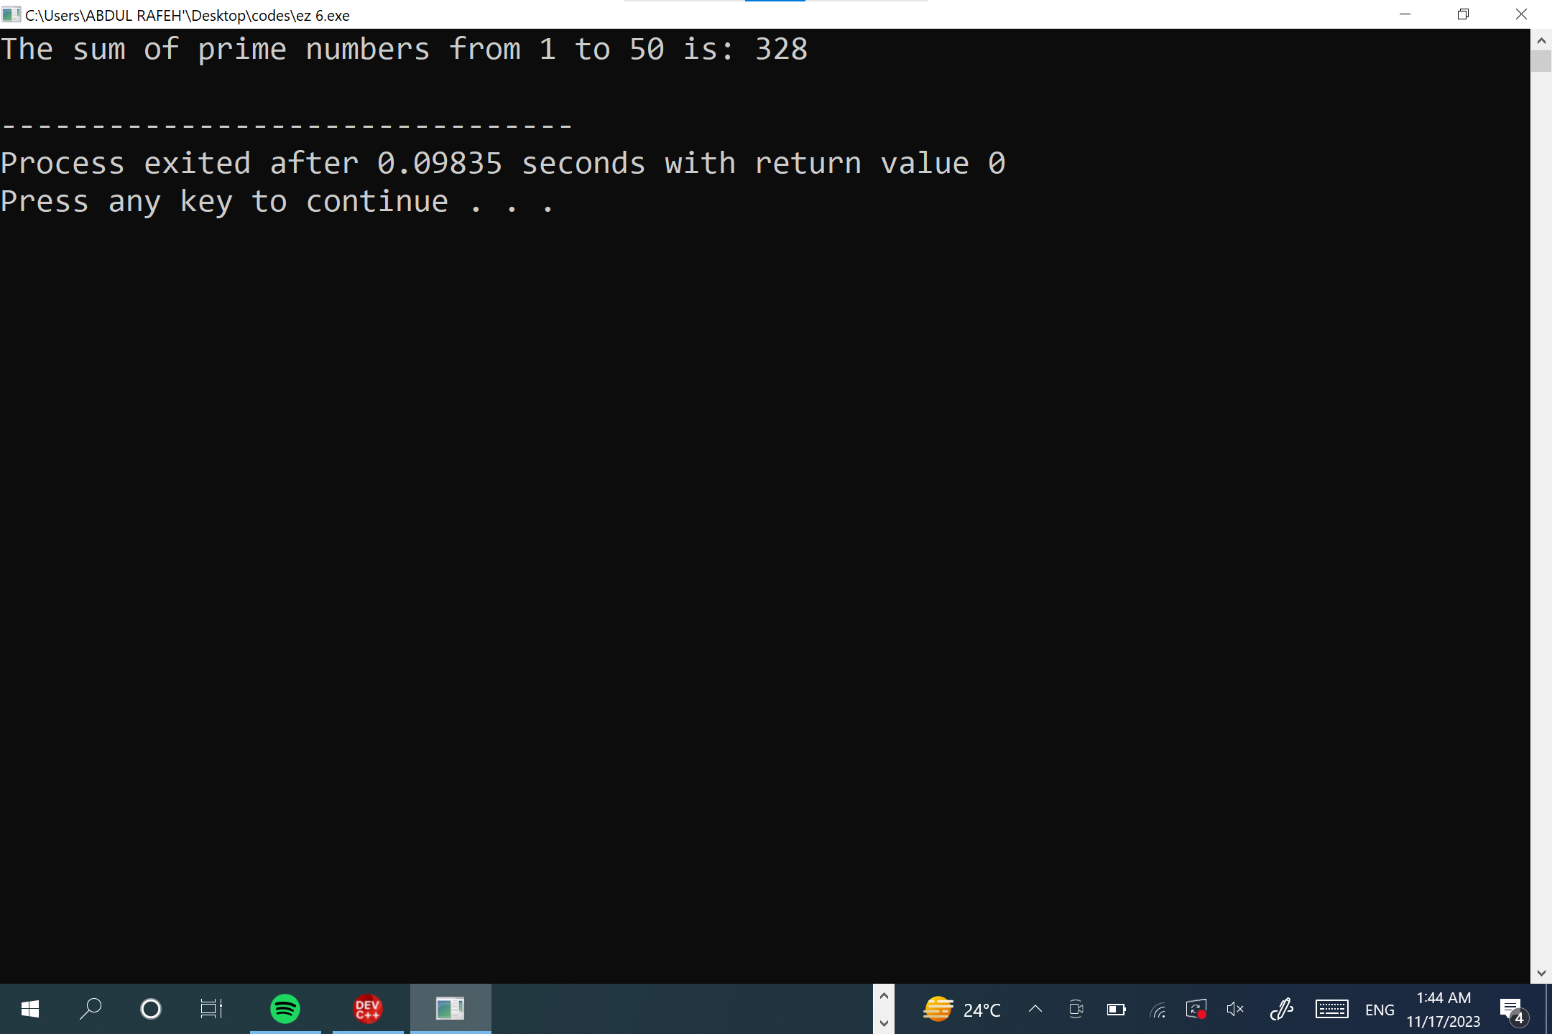

**PROGRAM 2:**

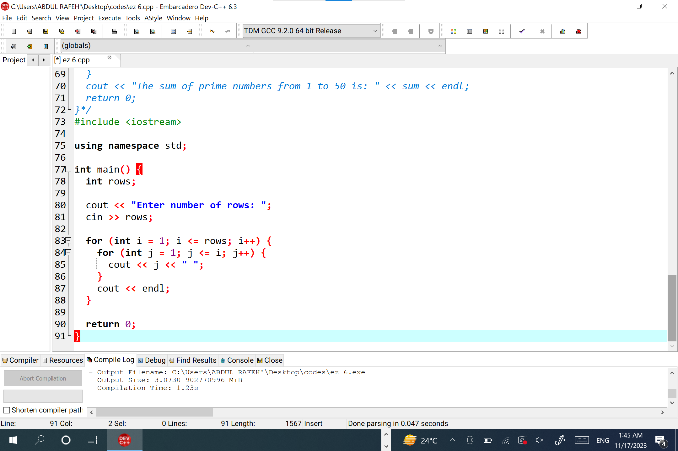

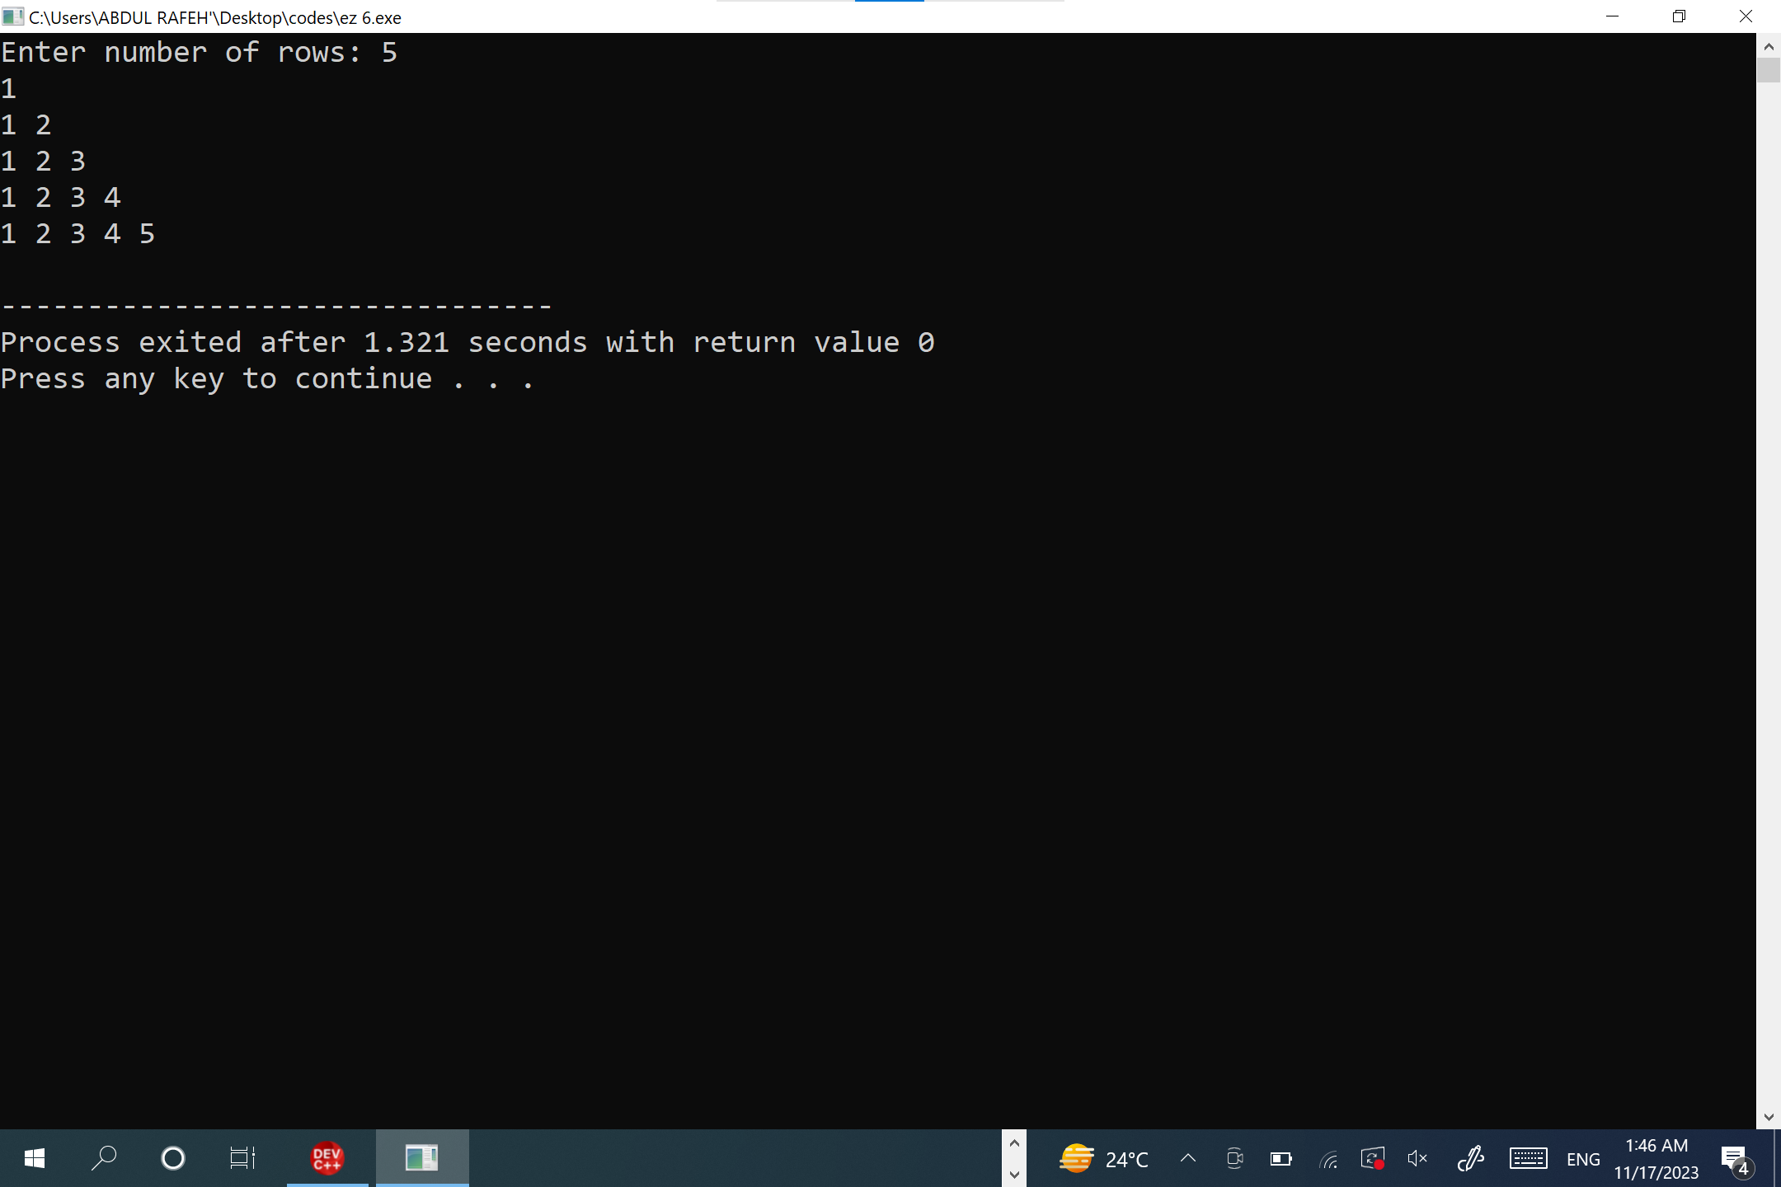

**PROGRAM 3:**

